U JEEVAN HARI

# CONTACT

## OBJECTIVE

Aspiring Full-Stack Developer with hands-on experience in ReactJS, NextJS, TypeScript, and PostgreSQL. Skilled in building scalable web applications, integrating APIs, and leveraging AI-powered coding tools to deliver impactful solutions

## INTERNSHIP AND TRAINING

+91 78929 25004

## TAP ACADEMY

Java Full Stack Developer

2025 - PRESENT

[jeevanhariwork@gmail.com](mailto:jeevanhariwork@gmail.com)

India

Hands-on training in building scalable full-stack applications with React, NextJS, REST APIs, PostgreSQL, and seamless database integration

https://github.com/jeevanhariwork

## COMPSOFT TECHNOLOGIES

Data Science Intern

2024 - 2025

# SKILLS

Developed "SmartSpoon – An AI-Powered Assistive Technology" to enhance taste perception using weak electric currents for individuals with dietary restrictions like hypertension and kidney diseases.

Acted as the Team Leader showcasing team work, leadership and Planning.

**Programming Languages**: Java, JavaScript,

## UDEMY

Java Course

Studiedfundamentals of Java, including OOP concepts, control structures,

2024

Python,

#### Tools:

arrays, methods and basic Data Structures and it focuses on building strong programminglogic and real-world application development.

## EDUCATION

Azure Data Factory

**Web Technologies**: HTML

### Bachelor of Engineering in CSE

Don Bosco Institute Of Technology, Bengaluru

#### PROJECTS

2021 - 2025

#### CGPA: 7.9

CSS

#### Databases:

MySQL

#### Framework:

React.js, Node.js, TailwindCSS

**Soft Skills**: Strong

**EmployeeLeave Management System**: (MySQL, HTML, CSS, PHP) Designed efficient database schemas and implemented leave tracking system using MySQL and PHP

**Pizza Time**: Built a responsive pizza ordering app with ReactJS and TailwindCSS, integrated backend API for order management, and deployed for testing.

**Earthquake Detection System**: Developed a deep learning model by integrating GAN, LSTM, attention mechanism, and neural networks to generatehigh-qualityseismic data, achieving 81% efficiency.

Communication, Time

Management, Teamwork,

### Pre-University Certificate

KLE Independent PU College, Bengaluru

2019- 2021

### 89%

Collaboration, Good

Elected as Class Representative, demonstrating leadership and responsibility.

Programming Skills

### Secondary School Leaving Certificate (SSLC)

The New Cambridge High School, Bengaluru

2018 - 2019

**84%**

# LANGUAGES

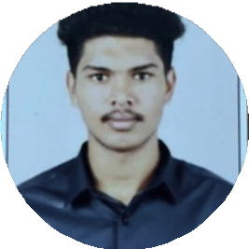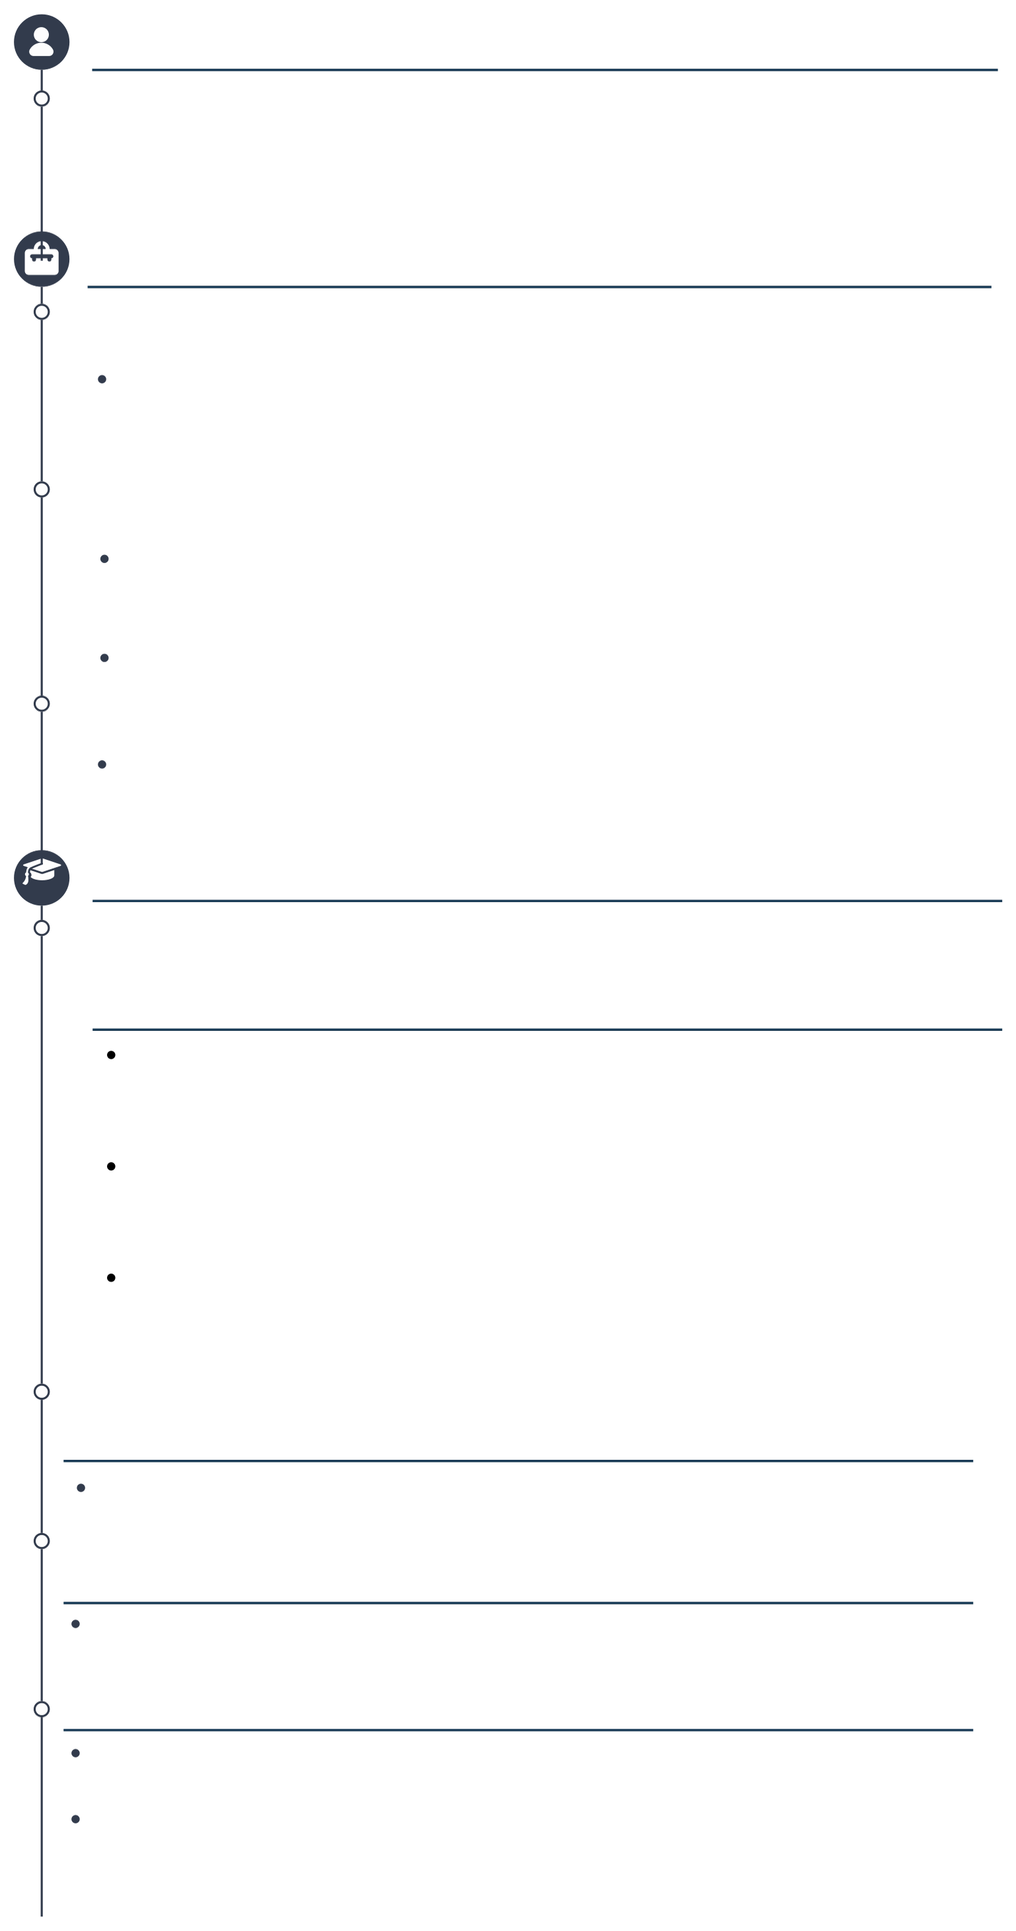

English Kannada Tamil

Actively participated in a team sports event, taking on the role of team leader whiledemonstrating leadership, strategic thinking, and strong focus.

## ACHIEVEMENTS

I am a proud cadet of the **NCC [National Cadet Corps]**, a premier national organization dedicated to fostering unity, discipline, leadership and teamwork. Worked as a volunteer in an event management firm, which helped develop essential skills like planning, time management.

Actively using AI-powered coding assistants (Cursor, Claude Code) to

optimize workflows and improve development velocity